City Of Mequon
Do you have an Illegal connection to the sanitary sewer system?

What is an illegal connection?
An illegal connection is any connection that drains clear water (rain or sump pump water) to the sanitary sewer system such as:
- Downspouts that discharge underground and are connected to the sanitary lateral.
- Sump pumps that are connected to a floor drain, stack pipe, or wash basin.
- Yard drains that are connected to a sanitary lateral.
Image Courtesy of Ron Graves, Ad Grafix, Inc. and the Muncie, IN Sanitary District

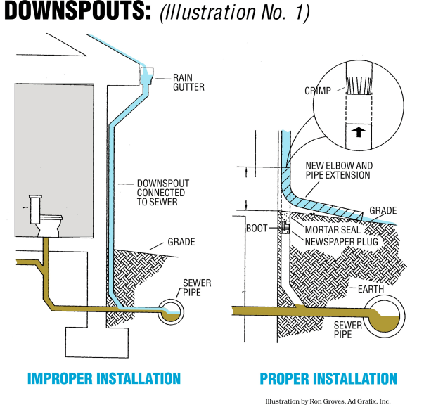
How does inflow impact the community?
Illegal connections may help keep your yard or ditch dry but during a rain event these connections can overwhelm a sanitary sewer
Inflow is rain or ground water that directly flows from a roof or sump pump via a conduit into the sanitary sewer system.
Sanitary sewer systems are only designed to accept waste flows and the inflow of clear water can easily overwhelm the sanitary sewer system causing basement backups.
An 8 inch sanitary sewer can handle domestic waste water flow from 200 homes, but only eight sump pumps, operating at full capacity, or six homes with downspouts connected to the sanitary sewer, will overload this same 8 inch line.

How do you determine an illegal connection?
Determine where your downspouts and sump pump discharge to. If your downspouts or sump pump discharge onto the ground, an approved drainage way or designated sump lateral then that is acceptable. If the location is unknown then further investigation may be warranted.
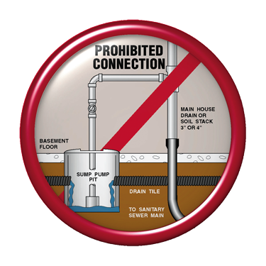 Image courtesy of Cedar Falls, Iowa

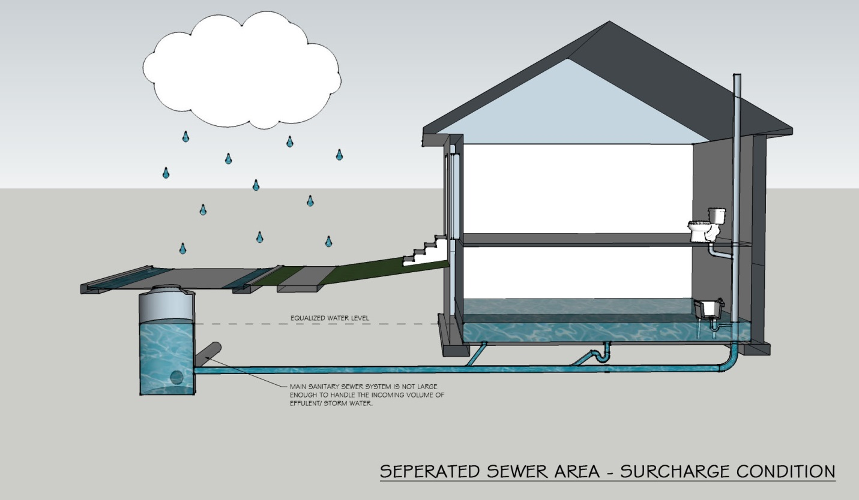
Image courtesy of Tom Zoulek, Mid City Plumbing

What can you do about an illegal connection?
- Disconnect any downspouts that are directly connected to a sanitary sewer. Cap the underground pipe
and extend downspouts 6-10 feet away from your home.
- Disconnect any sump pumps that are directly connected to the sanitary sewer. Discharge to grade or underground to a garden or ditch. Make sure that your discharge pipe is far enough away from your foundation and that the discharge location conforms to Mequon’s plumbing code.
- Disconnect yard drains from the sanitary sewer. Discharge drains to ditches or re-grade your yard to improve drainage.
What do you do with the excess water?
Now that you have disconnected your sump pump and downspouts, your property will have to manage the storm and clear water. Water should be directed to an approved drainage way or roadway, and not on a neighbor’s property.
- Ensure there is positive grade away from your foundation for at least the first 6 feet.
- Divert excess water to the storm sewer or ditch line.
- Divert excess water to rain gardens or an infiltration basin.
- Harvest water using rain barrels and re-use for non-potable uses such as irrigation or car washing.
For More Information Please Visit: Milwaukee Metropolitan Sewage District www.mmsd.com
UW-Extension’s Website http://clean-water.uwex.edu/pubs/
For Further information please contact the Deputy Director of Utilities Kevin Driscoll
Phone: 262-236-2934
Email: kdriscoll@ci.mequon.wi.us

