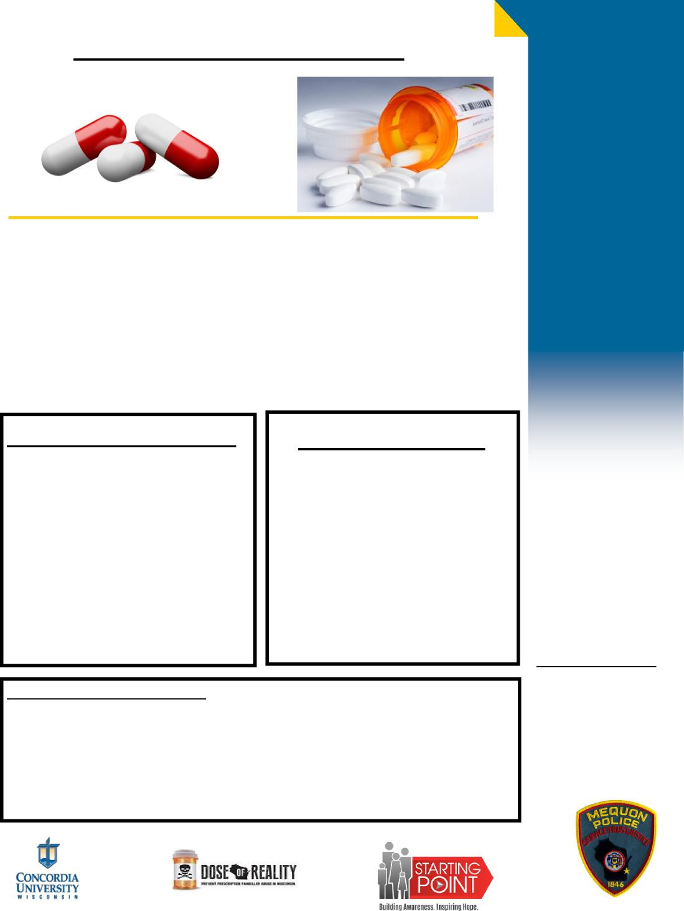

**:**

**DO NOT BRING**

DRUG TAKE BACK DAY

**SAFE**

**DISPOSAL,**

**SAVES**

**LIVES !!!**

**SATURDAY, April 30th, 2022—10:00AM-2:00PM**

**CONCORDIA UNIVERSITY WISCONSIN**

**12800 N. LAKESHORE DRIVE**

**MEQUON,WI 53097**

**Mequon Police Department 11300 N Buntrock Ave Mequon, WI 53092**

**More Information Call Phone: 262**-**242**-**3500**

**Fax: 262**-**242**-**7655** [**Www.mequonpd.com**](http://Www.mequonpd.com)

**WHAT YOU CAN BRING:**

*Expired & Unwanted Prescription

Medication

. Vitamin and Herbal Medicine

. Over-the-Counter Medicine

. Veterinary Medicine

. Medicated Liquids, Ointments,

and Creams

* Illegal Drugs

. Biohazardous Materials . Personal Care Products

. Household Hazardous Wastes

**HOW DOES THE COLLECTION WORK?**

**. Please keep medication in the original package or bottle**

**. DO NOT cover up or remove the name of the medications**

**. Drive through the drop**-**off area and hand your medications to a student, pharmacist or**

**Volunteer.**